Sensing Techonologies
Information Techonology is built on tree main pillars: computers, communications, and sensing technologies. Sensing technologies are an important indicator to measure a country's informatization level. Sensing technology refers to sensors that can sense something about the ambient environment or that detect some special substance.
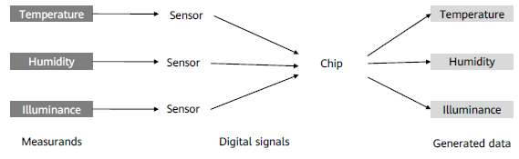
Sensors
A sensor is a device that senses a measurand and converts it into a usable signal based on certain
rules.
Application Scenarios
Sensors are used in the military, energy, robotics, automatic control, environmental protection,
transportation, healthcare, household appliances, remote sensing, and chemicals industries.
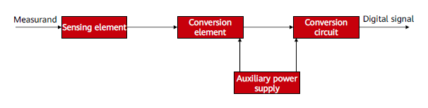
IoT devices collect a lot of data. Device data comes from sensors.
Sensor Classification
Sensors can be classified using different methods:
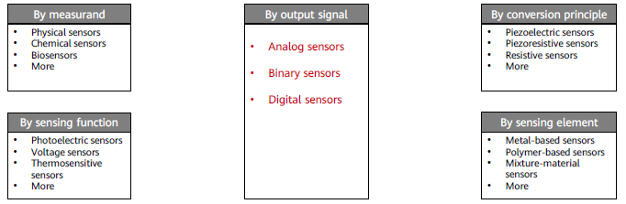
Analog Sensors
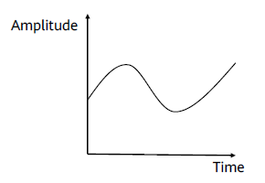
Analog sensors output continuous signals and present measurand values using voltage, current, and temperature. The figure shows the current signal output by a thermistor. Any value on the curve represents a temperature value.

Binary Sensors
Signals output by binary sensors are not continuous. Binary sensors reflect two status signals: open and closed, similar to 1 and 0 of digital sensors. They are the most typical type of sensors and are used to detect object statuses, actions, or positions.
Digital Sensors
Digital sensors transform the A/D conversion modules of analog sensors to output digital signals. A digital sensor contains an amplifier, analog-to-digital converter (ADC), microprocessor, memory, communication interfaces, and temperature detection circuit. Digital sensors convert analog quantities into digital quantities in four steps: sampling, holding, quantization, and encoding. Analog-to-digital conversion formula:
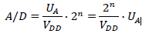
Where
𝐴/𝐷: digital quantity
𝑈𝐴: analog quantity
𝑛: ADC resolution (number of bits)
𝑉𝐷𝐷: power supply voltage of the conversion circuit
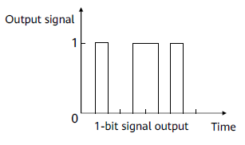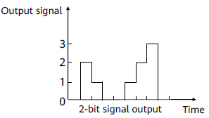

Working Principles of Common Sensors
- Temperature Sensors
Temperature sensors sense temperatures and convert them into usable signals. Based on the characteristics of the sensing materials and electronic components used, temperature sensors can be classified as resistance temperature detectors (RTDs) or thermocouple sensors.
- Humidity Sensors
Humidity sensors can sense environmental humidity changes and convert non-electrical quantities into electrical ones by detecting physical or chemical changes. They can be classified as resistive or capacitive sensors.
- Photoelectric Sensors
Photosensitive sensors use photosensitive elements to convert optical signals into electrical signals. Their physical basis is the photoelectric effect. Many electrical features of semiconductor materials change when exposed to light. There are three types of photoelectric effects: external, internal, and photovoltaic.
- Infrared Sensors
An infrared sensor consists of an optical system, a detecting element, and a conversion circuit. Optical systems can be classified based on their structure as either transmission or reflection system. Detecting elements can be classified as thermosensitive or photoelectric elements, depending on how they work.

